Order Of Service

Singing: Psalm 34—CW page 80

Reading: Psalm 25

Opening Hymn: TLH 63

Reading: Revelation 7:9-17

Request Hymn: CW Supplement 748

Reading: John 6:35-51

Sermon Hymn: TLH 339

Sermon Text: Song Of Solomon 5:4

The Hand Of God

Prayer

The Apostles’ Creed, TLH page 12

Holy Communion

The Lord's Prayer

The Blessing

Closing Hymn: TLH 54

* * * * * * * * * * *

Koinonia Hour

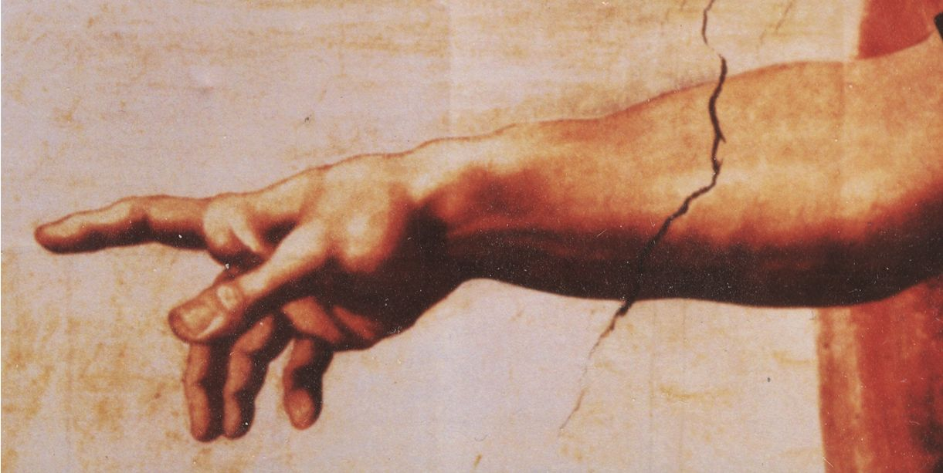

The Hand Of God

Water
Of
Life

4 December 2016

W A T E R O F L I F E

Independent Christian Church—Conservative Lutheran Doctrine

Worship Service: 9:30 a.m. Bible Study: 10:45 a.m.

Larry Cooper, Pastor E-Mail address:
111 N. Ridge Road lcooper@wateroflife.cc
Coon Valley, WI 54623 Web Site:
Phone: (608) 452-2105 www.wateroflife.cc

* * * * * * * * * * * * * * * * * * * * * * * * * * *

Sermon Text: Song Of Solomon 5:4

The Hand Of God

* * * * * * * * * * * * * * * * * * * * * * * * * * *

Song of Solomon 5:4 My beloved put in his hand by the hole of the door, and my bowels were moved for him.

We have in this verse an amazing miracle! Consider the Bride of Christ as the Holy Spirit records for us in Song Of Solomon 5:2-3:

2 I sleep, but my heart waketh: it is the voice of my beloved that knocketh, saying, Open to me, my sister, my love, my dove, my undefiled: for my head is filled with dew, and my locks with the drops of the night. 3 I have put off my coat; how shall I put it on? I have washed my feet; how shall I defile them?
But now what a change has taken place! My bowels were moved for him! And it was all brought about by the Bridegroom! My beloved put in his hand by the hole of the door!



In Scripture the hand of God often speaks of his power.

Exodus 15:6 Thy right hand, O LORD, is become glorious in power: thy right hand, O LORD, hath dashed in pieces the enemy.

Acts 11:21 And the hand of the Lord was with them: and a great number believed, and turned unto the Lord.

What we have here is a miracle performed by the Son of God and the Holy Spirit! It is performed on the heart of the Bride of Christ. She had nothing to do with it. The miracle was performed on her, but not by her.

